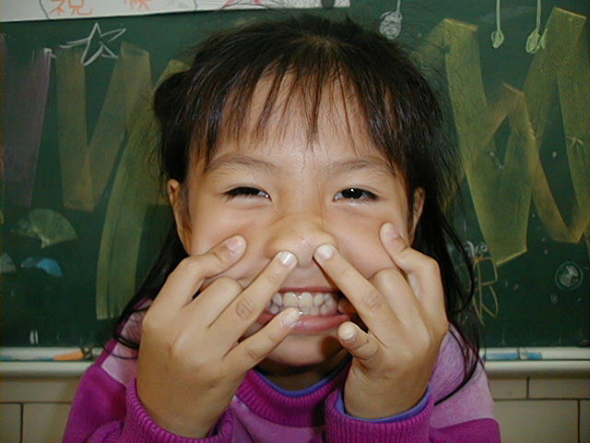
頂六國小三年智班扮鬼臉比賽學習單 我是：
The worksheets of “funny face “game in 3A of Dinlio elementary school I am…

The most terrible face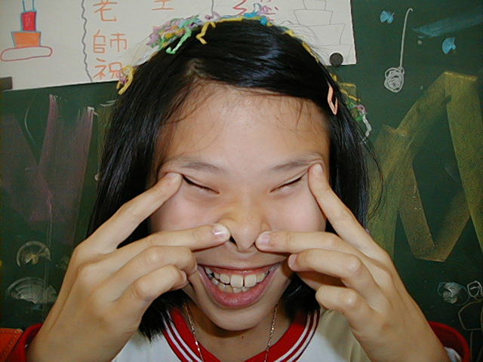
我覺得”第一恐怖”的鬼臉是：育勳
I feel the first winner is :
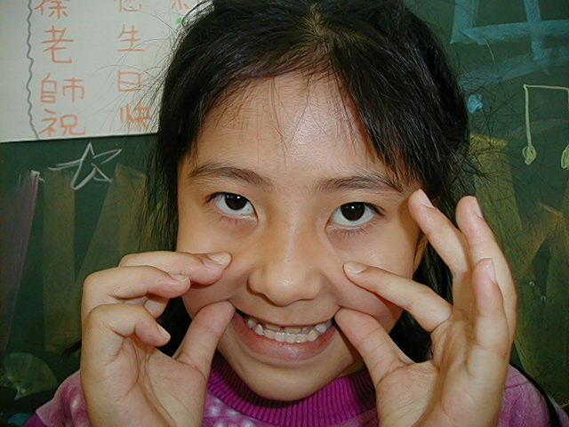
我覺得”第二恐怖”的鬼臉是：瑩庭
I feel the second winner is :
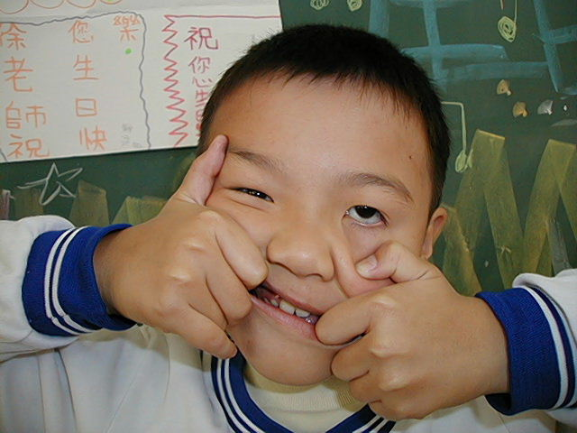
我覺得”第三恐怖”的鬼臉是正尉
I feel the third winner is : 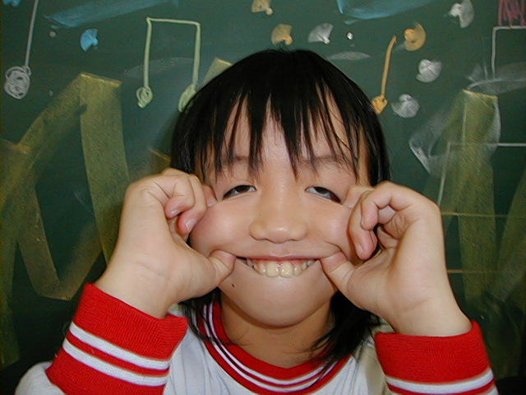

The most fuuny face
我覺得”第一可愛”的鬼臉是：又甄
I feel the first winner is :
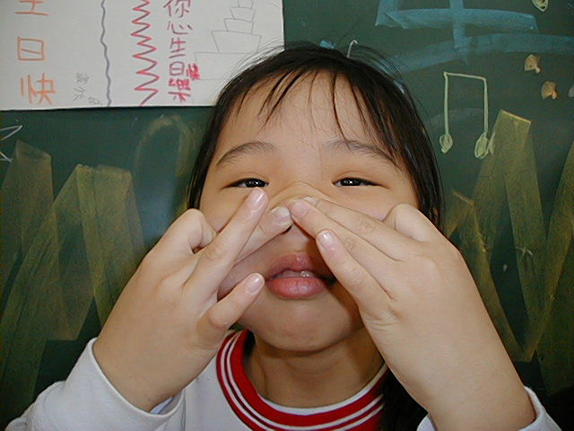
我覺得”第二可愛”的鬼臉是：虹君
I feel the second winner is :

我覺得”第三可愛”的鬼臉是：瑩庭
I feel the third winner is :

我的感想：好可愛又很恐布
My feeling:
Funny & fearful!

