頂六國小三年智班扮鬼臉比賽學習單 我是：淑雲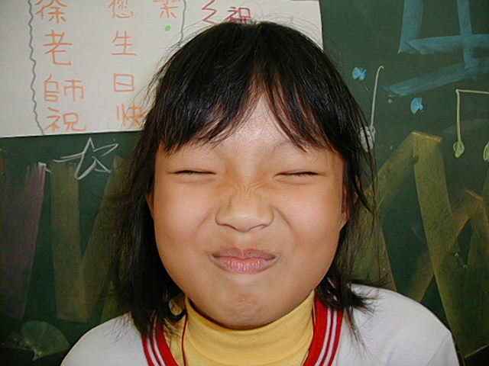
The worksheets of “funny face “game in 3A of Dinlio elementary school I am…
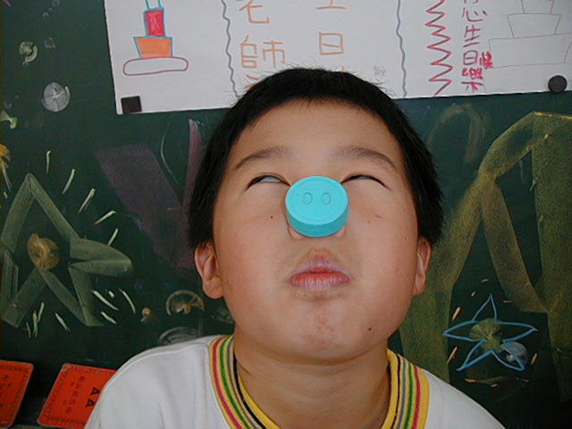

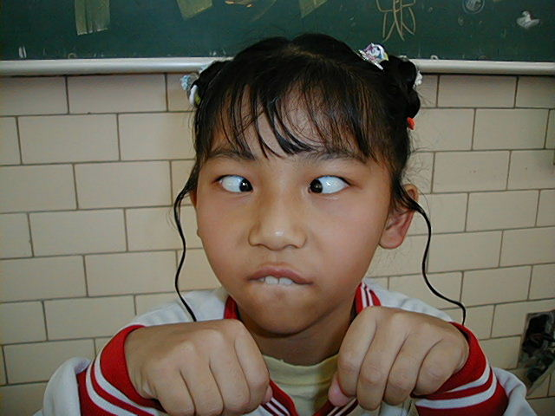
The most terrible face
我覺得”第一恐怖”的鬼臉是：睿之
I feel the first winner is :

我覺得”第二恐怖”的鬼臉是育勳
I feel the second winner is :
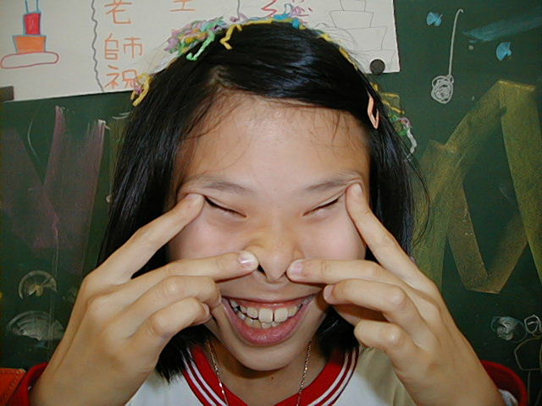
我覺得”第三恐怖”的鬼臉是：弘偉
I feel the third winner is :
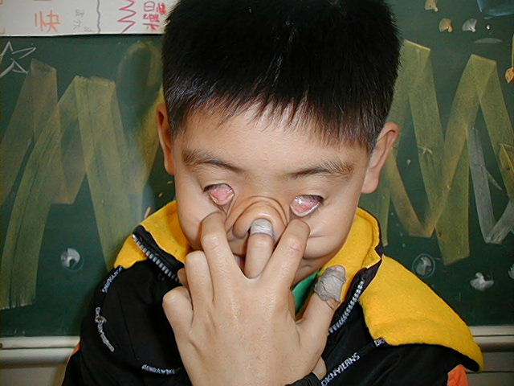

The most fuuny face
我覺得”第一可愛”的鬼臉是：薏如
I feel the first winner is :
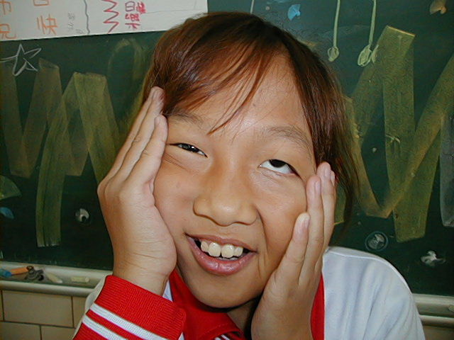
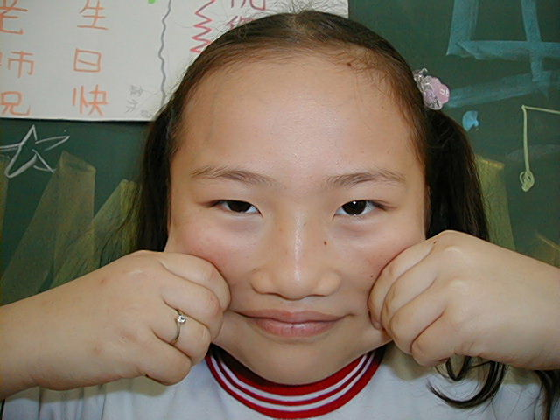
我覺得”第二可愛”的鬼臉是：婉菱
I feel the second winner is :
我覺得”第三可愛”的鬼臉是：采茹
I feel the third winner is :

我的感想：像下面那張照片是不是很可愛呀,像有些可怕,好好笑
My feeling: Ex the under of image . That is few fearful and few fuuny!
