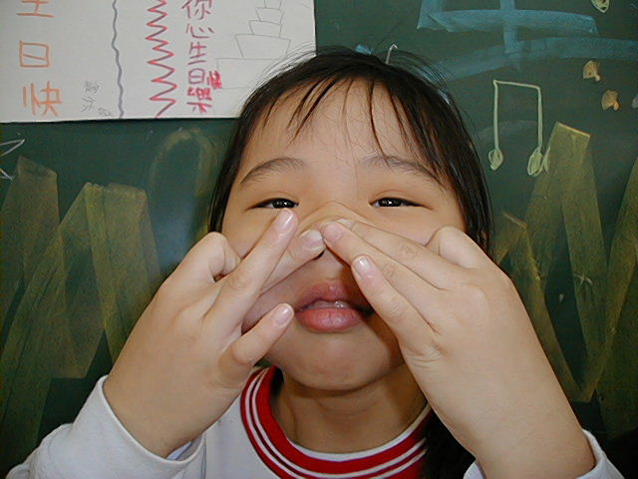
頂六國小三年智班扮鬼臉比賽學習單 我是：虹君
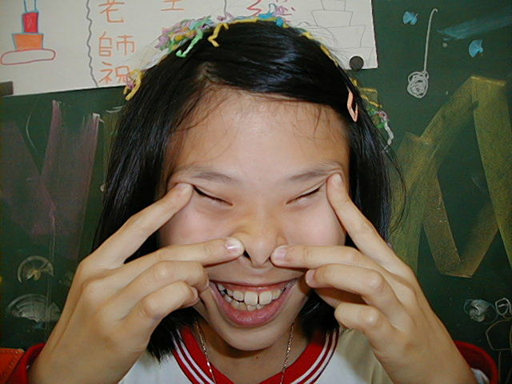
The worksheets of “funny face “game in 3A of Dinlio elementary school I am…

The most terrible face
我覺得”第一恐怖”的鬼臉是：育勳
I feel the first winner is :
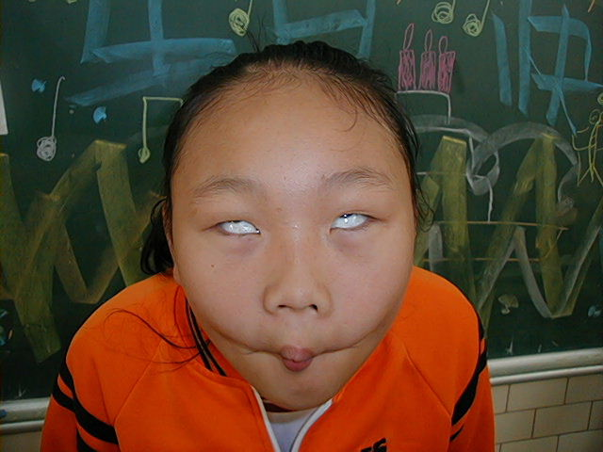
我覺得”第二恐怖”的鬼臉是：毓倚
I feel the second winner is :

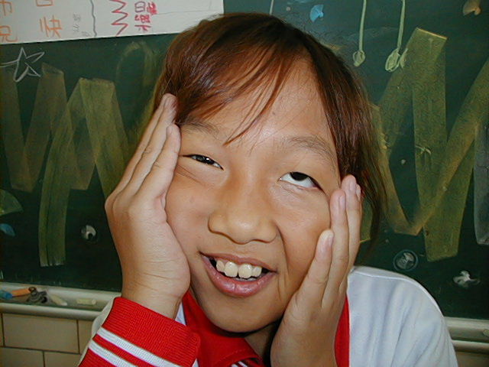
我覺得”第三恐怖”的鬼臉是：婉菱
I feel the third winner is :

The most fuuny face
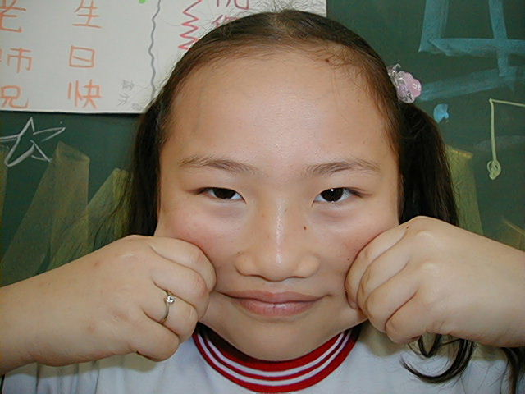
我覺得”第一可愛”的鬼臉是：薏如
I feel the first winner is :

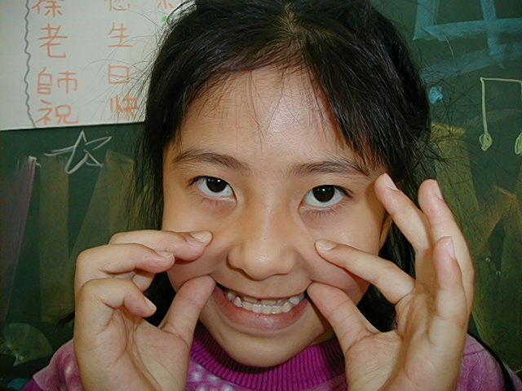
我覺得”第二可愛”的鬼臉是：瑩庭
I feel the second winner is :

我覺得”第三可愛”的鬼臉是：淑雲
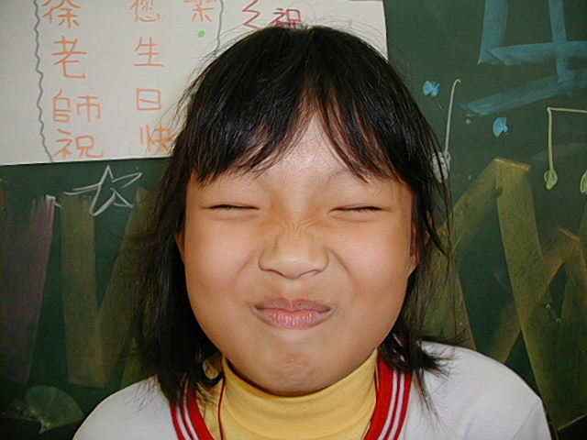
I feel the third winner is :

我的感想：扮鬼臉好玩又有趣
My feeling:
Funny & Interesting!

