頂六國小三年智班扮鬼臉比賽學習單 我是：
The worksheets of “funny face “game in 3A of Dinlio elementary school I am…

The most terrible face
我覺得”第一恐怖”的鬼臉是：I feel the first winner is :弘偉
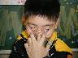
我覺得”第二恐怖”的鬼臉是： I feel the second winner is :毓倚
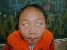
我覺得”第三恐怖”的鬼臉是： I feel the third winner is :長奇
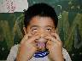

The most fuuny face
我覺得”第一可愛”的鬼臉是：
I feel the first winner is :婉菱
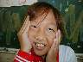
我覺得”第二可愛”的鬼臉是：
I feel the second winner is :惠珊
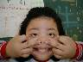
我覺得”第三可愛”的鬼臉是：
I feel the second winner is : 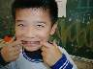昌麟
我的感想:鬼臉有的好可愛,有的粉恐怖喔!!!! My feeling:
Some funny! Some fearful!

