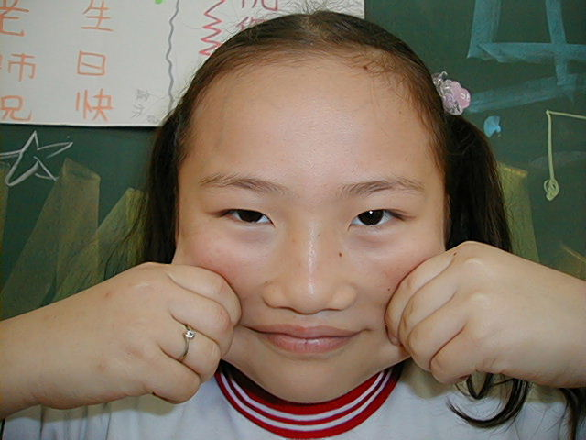
頂六國小三年智班扮鬼臉比賽學習單 我是：薏如
The worksheets of “funny face “game in 3A of Dinlio elementary school I am…

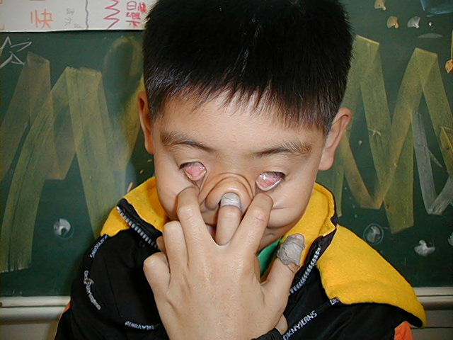
The most terrible face
我覺得”第一恐怖”的鬼臉是：陳弘偉
I feel the first winner is :

我覺得”第二恐怖”的鬼臉是：有仁
I feel the second winner is :
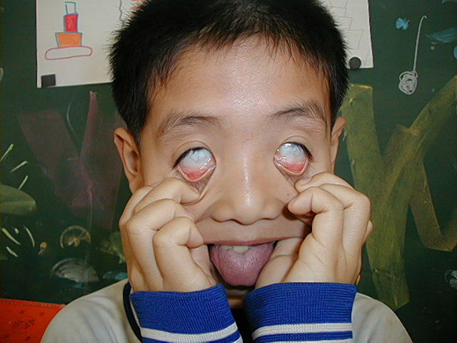
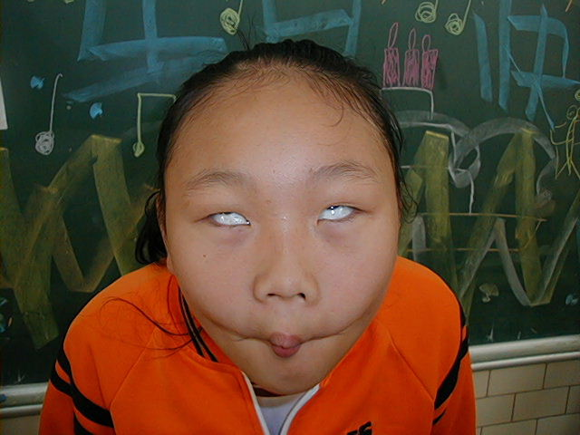
我覺得”第三恐怖”的鬼臉是：毓倚
I feel the third winner is :

The most fuuny face
我覺得”第一可愛”的鬼臉是：采茹
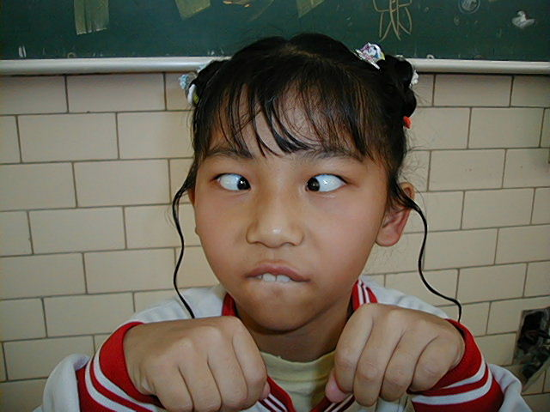
I feel the first winner is :
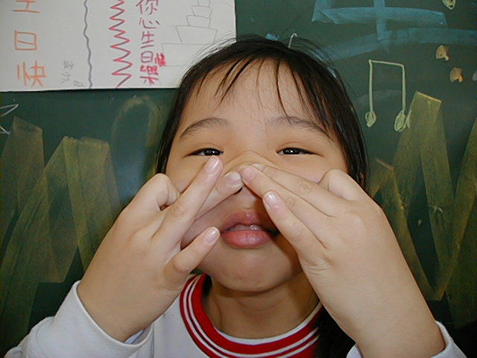
我覺得”第二可愛”的鬼臉是：劉虹君
I feel the second winner is :

我覺得”第三可愛”的鬼臉是：宜洋
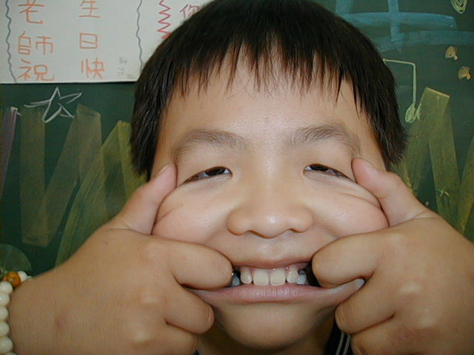
I feel the third winner is :

我的感想：真希望老師下次能再舉辦好玩的扮鬼臉比賽~~!
My feeling: I hope to play the funny face next time.

