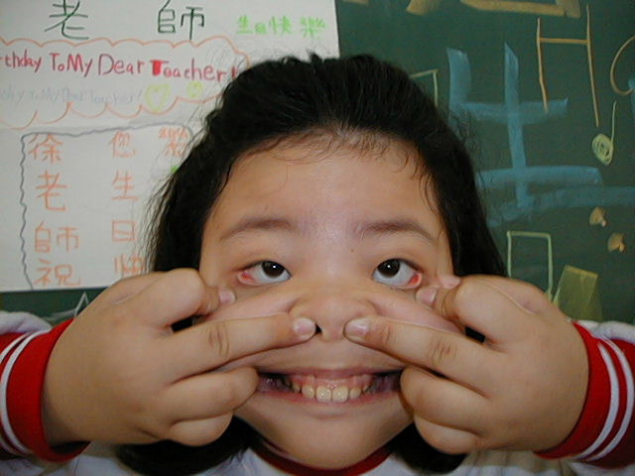
頂六國小三年智班扮鬼臉比賽學習單 我是：惠珊
The worksheets of “funny face “game in 3A of Dinlio elementary school I am…
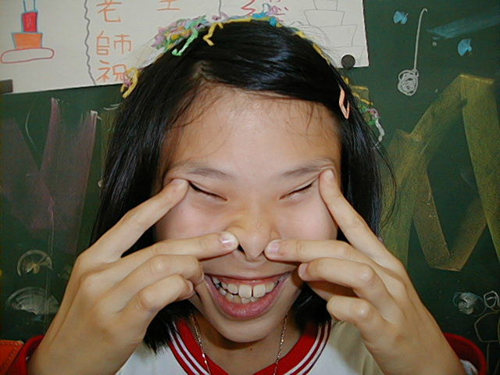

The most terrible face
我覺得”第一恐怖”的鬼臉是：育勳
I feel the first winner is :
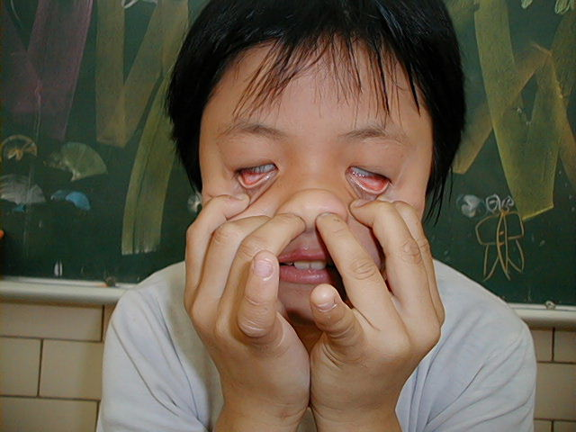
我覺得”第二恐怖”的鬼臉是：玫苑
I feel the second winner is :
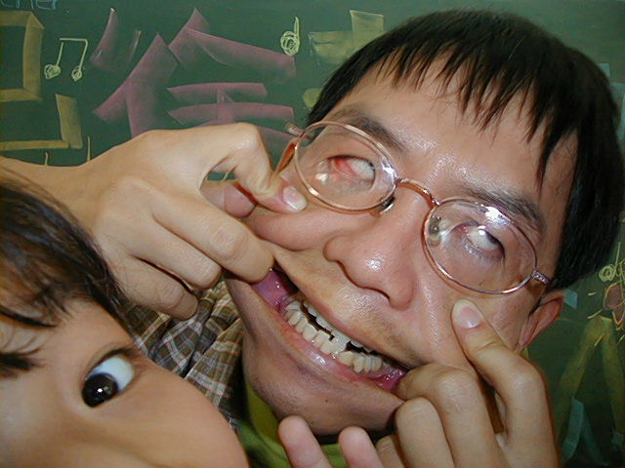
我覺得”第三恐怖”的鬼臉是：進宗
I feel the third winner is :

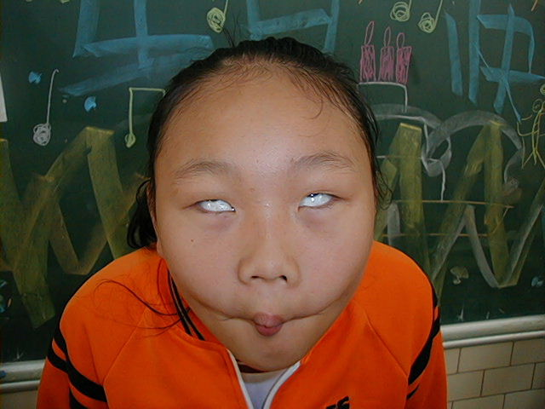
The most fuuny face
我覺得”第一可愛”的鬼臉是：毓倚
I feel the first winner is :
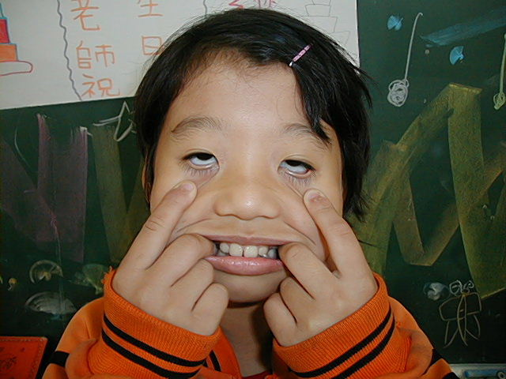
我覺得”第二可愛”的鬼臉是：姿諱
I feel the second winner is :
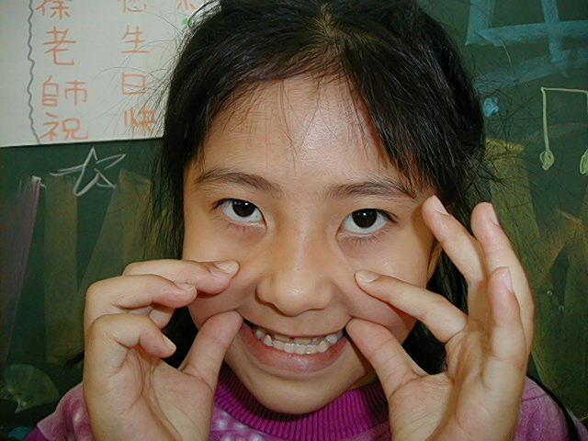
我覺得”第三可愛”的鬼臉是：瑩庭
I feel the third winner is :
我的感想：我覺得裡面最恐怖的是育勳 ,所以我相信冠軍非她莫屬 .
My feeling:
Liao Yu Xun is very fearful! I think her can get a champion.

