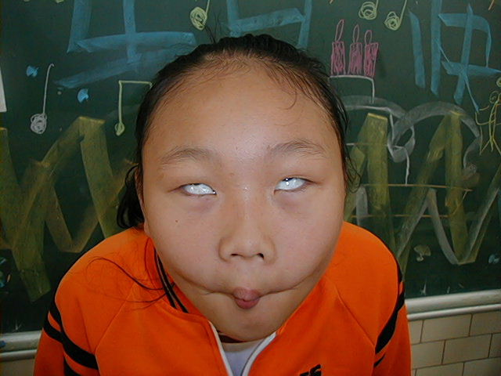
頂六國小三年智班扮鬼臉比賽學習單 我是:毓倚
The worksheets of “funny face “game in 3A of Dinlio elementary school I am…

The most terrible face
我覺得”第一恐怖”的鬼臉是：育勳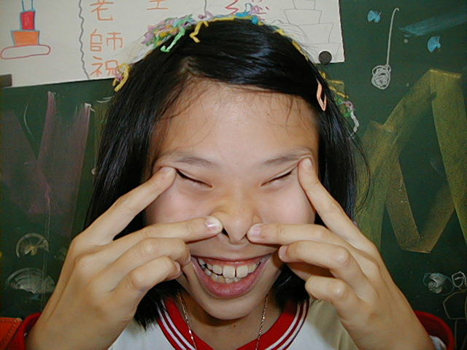
I feel the first winner is :
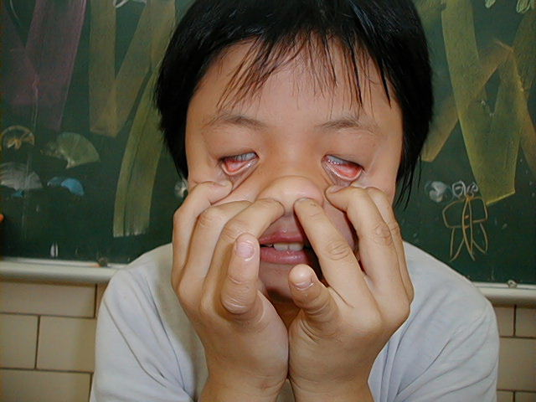
我覺得”第二恐怖”的鬼臉是：玫苑
I feel the second winner is :

我覺得”第三恐怖”的鬼臉是：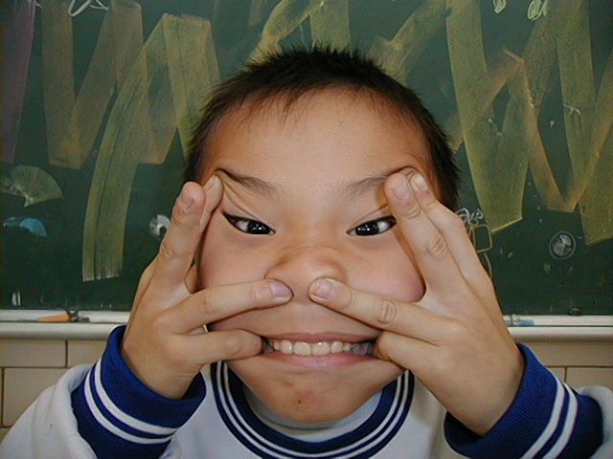
I feel the third winner is :

The most fuuny face
我覺得”第一可愛”的鬼臉是：睿之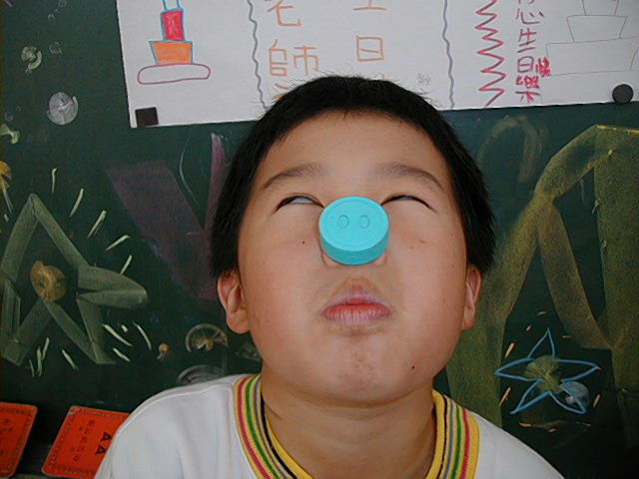
I feel the first winner is :

我覺得”第二可愛”的鬼臉是：弘偉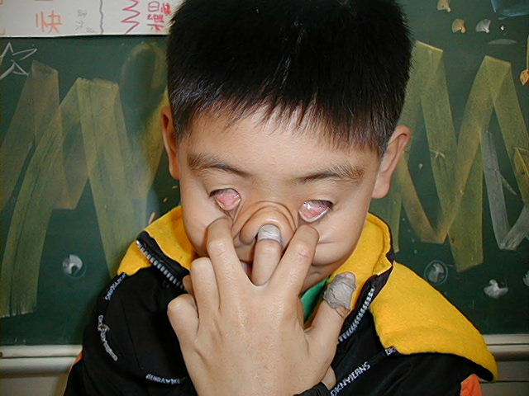
I feel the second winner is :

我覺得”第三可愛”的鬼臉是：宜洋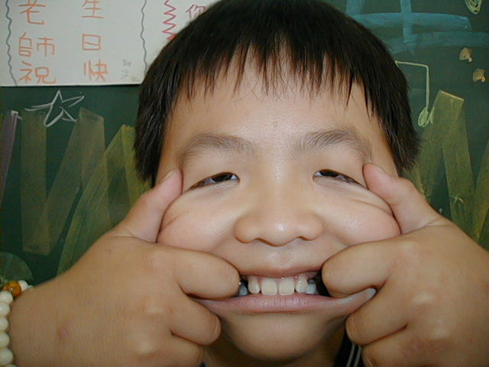
I feel the third winner is :
我的感想：這次活動很有趣希望能在辦
My feeling: Wish play funny face next time.

