頂六國小三年智班扮鬼臉比賽學習單 我是：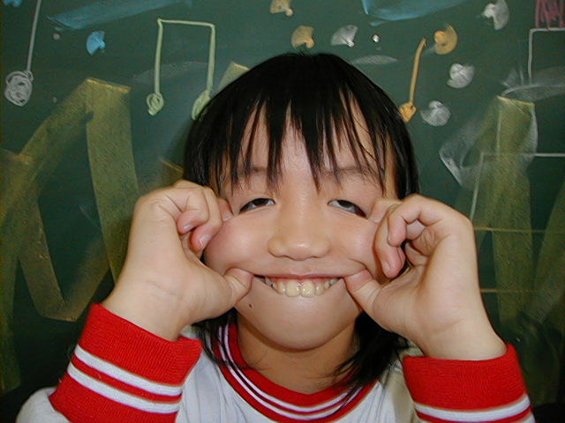
The worksheets of “funny face “game in 3A of Dinlio elementary school I am…
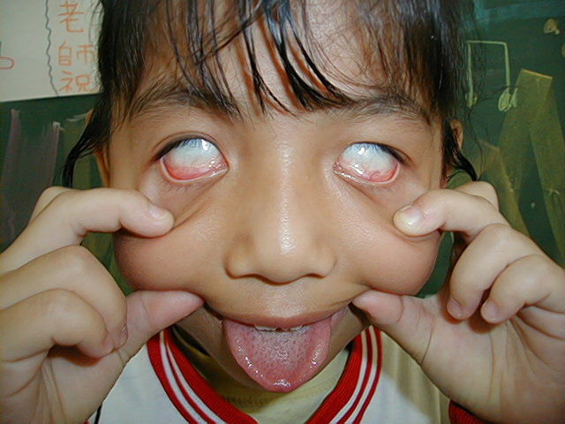

The most terrible face
我覺得”第一恐怖”的鬼臉是：
I feel the first winner is :
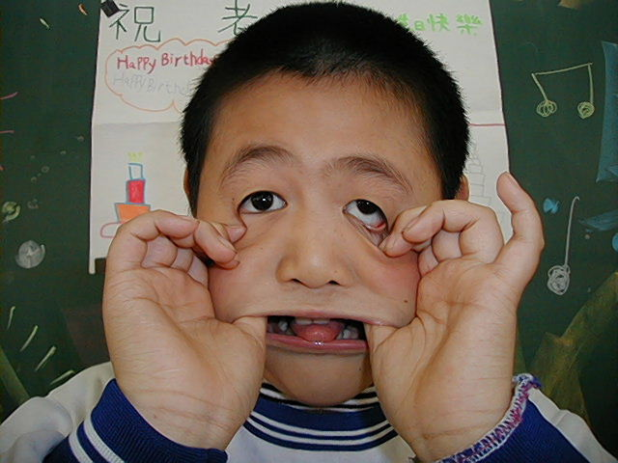
我覺得”第二恐怖”的鬼臉是：
I feel the second winner is :
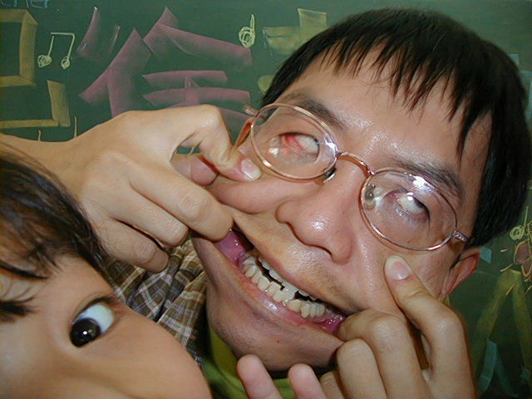
我覺得”第三恐怖”的鬼臉是：
I feel the third winner is :


The most fuuny face
我覺得”第一可愛”的鬼臉是：
I feel the first winner is :
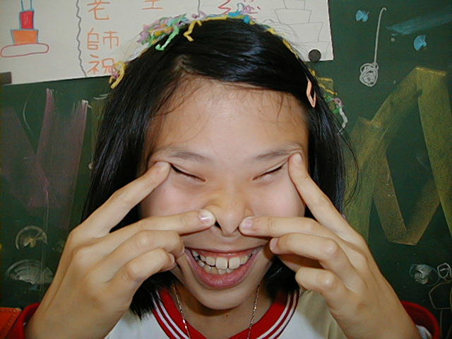
我覺得”第二可愛”的鬼臉是：
I feel the second winner is :
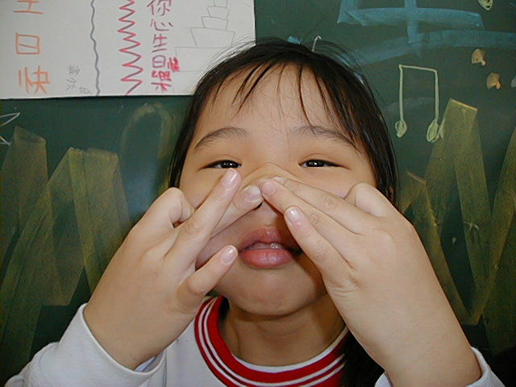
我覺得”第三可愛”的鬼臉是：
I feel the third winner is :

我的感想：我覺得扮鬼臉很好笑
My feeling:
To play “funny face “ are interesting!

