頂六國小三年智班扮鬼臉比賽學習單 我是：長奇
The worksheets of “funny face “game in 3A of Dinlio elementary school I am…
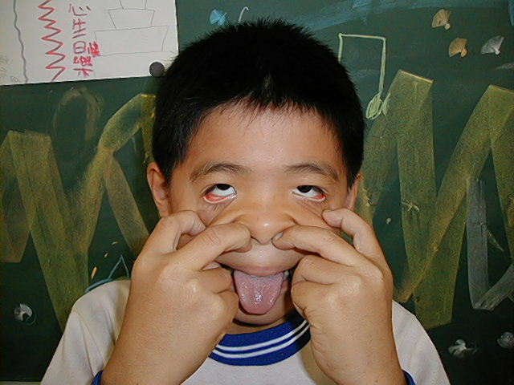老師

The most terrible face
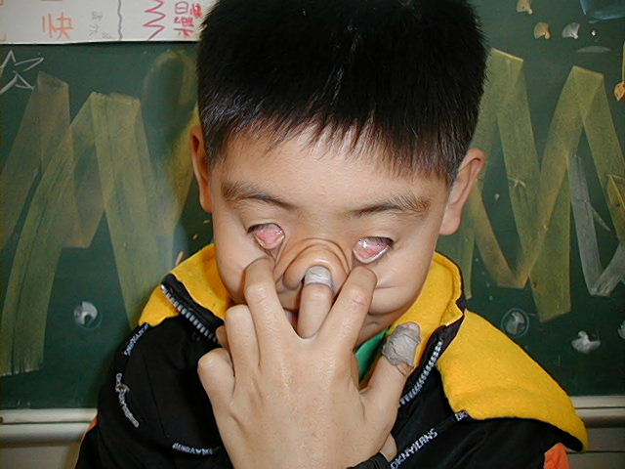
我覺得”第一恐怖”的鬼臉是：弘偉
I feel the first winner is :


我覺得”第二恐怖”的鬼臉是：老師
I feel the second winner is :

我覺得”第三恐怖”的鬼臉是：長奇

The most fuuny face
我覺得”第一可愛”的鬼臉是：意如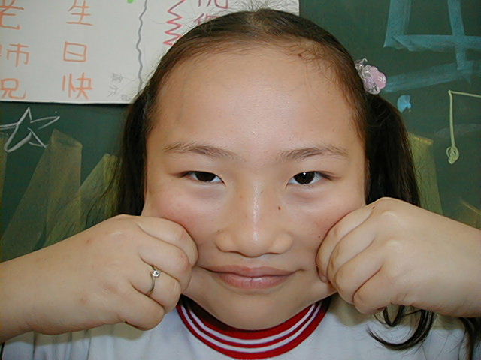
I feel the first winner is 我覺得”第二可愛”的鬼臉是：睿之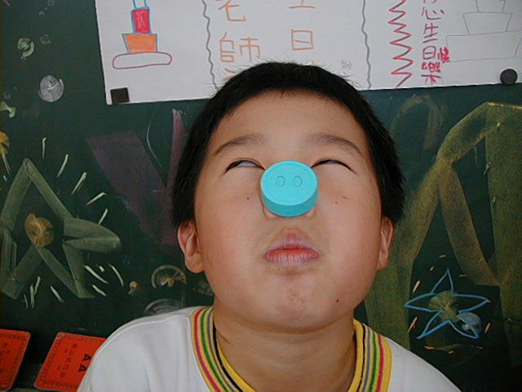
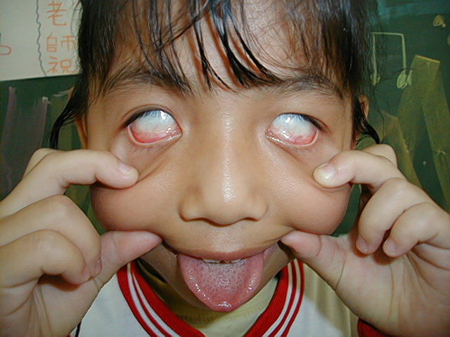
I feel the second winner is :

我覺得”第三可愛”的鬼臉是：采如
我的感想 我覺得陳意如是全班最
可愛一位
My feeling：:Yi Ru is the most loveable child
in our classroom.

