頂六國小三年智班扮鬼臉比賽學習單 我是：睿之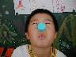
The worksheets of “funny face “game in 3A of Dinlio elementary school I am…

The most terrible face
我覺得”第一恐怖”的鬼臉是：景發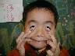
I feel the first winner is :

我覺得”第二恐怖”的鬼臉是：毓倚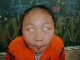
I feel the second winner is :

我覺得”第三恐怖”的鬼臉是：弘偉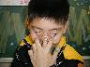
I feel the third winner is :

The most fuuny face
我覺得”第一可愛”的鬼臉是：薏如
I feel the first winner is :

我覺得”第二可愛”的鬼臉是：宜洋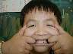
I feel the second winner is :

我覺得”第三可愛”的鬼臉是：宇軒0.3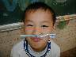
I feel the third winner is :

我的感想：這次的扮鬼臉比賽多虧了老師生日
My feeling：Thanks our teacher’s birthday!

