頂六國小三年智班扮鬼臉比賽學習單 我是：翔尹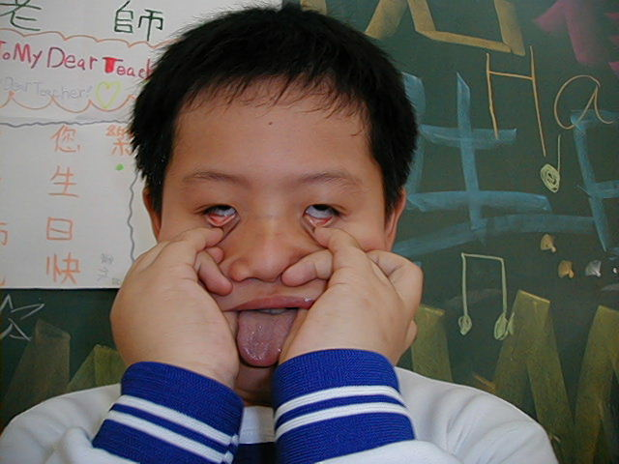
The worksheets of “funny face “game in 3A of Dinlio elementary school I am…

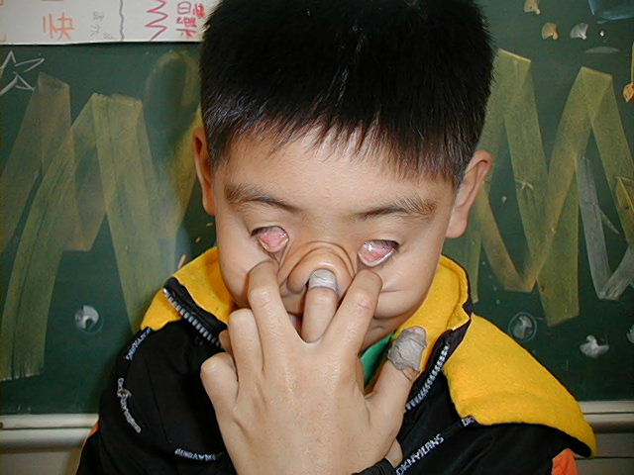
The most terrible face
我覺得”第一恐怖”的鬼臉是：弘偉
I feel the first winner is :

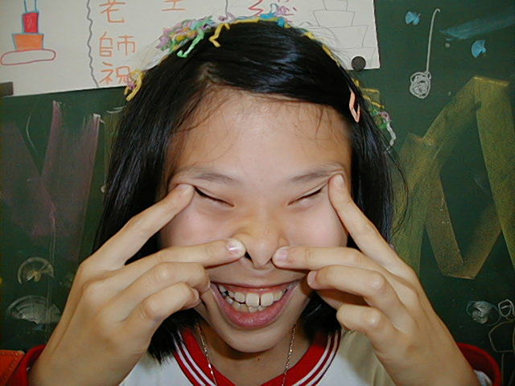
我覺得”第二恐怖”的鬼臉是：育勳
I feel the second winner is :

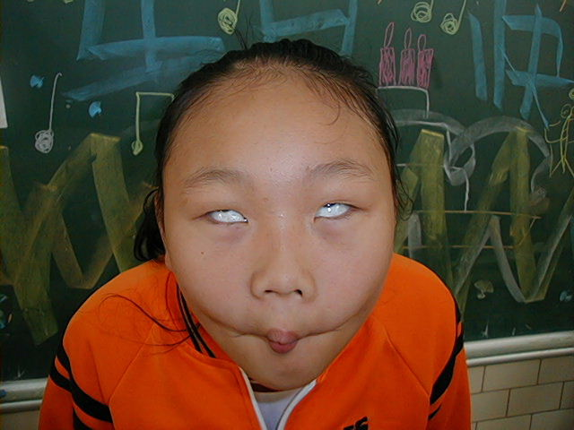
我覺得”第三恐怖”的鬼臉是：毓倚
I feel the third winner is :

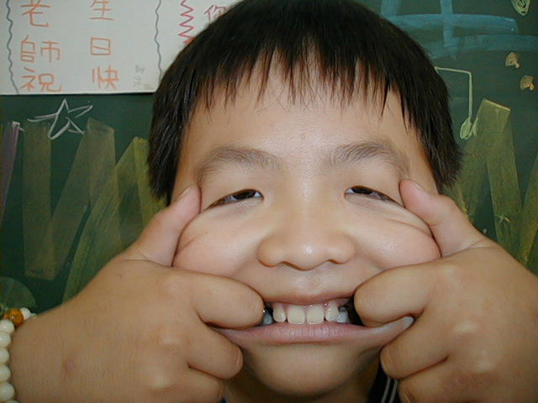
The most fuuny face
我覺得”第一可愛”的鬼臉是：宜洋
I feel the first winner is :
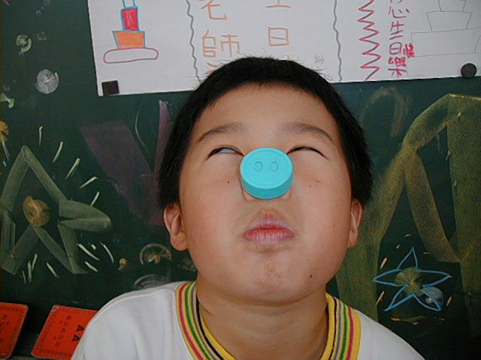
我覺得”第二可愛”的鬼臉是：睿之
I feel the second winner is :
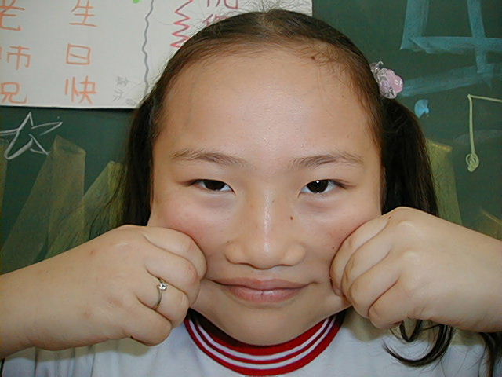
我覺得”第三可愛”的鬼臉是：薏如
I feel the third winner is :

我的感想： 我覺得大家表現的都好
My feeling：Every body have a good funny face show.

