頂六國小三年智班扮鬼臉比賽學習單 我是：弘偉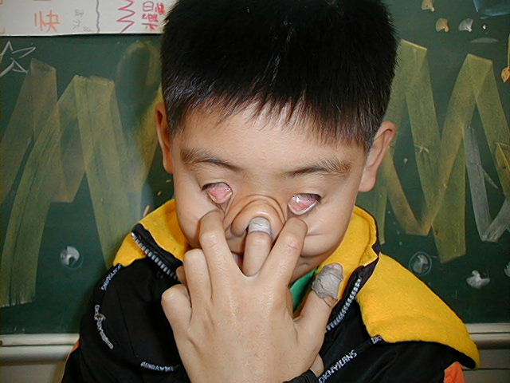
The worksheets of “funny face “game in 3A of Dinlio elementary school I am…

The most terrible face
我覺得”第一恐怖”的鬼臉是：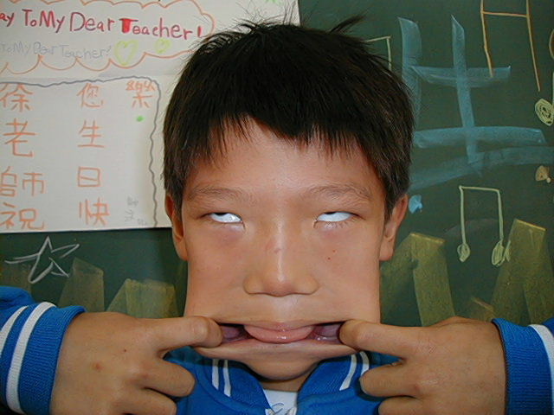建杰

I feel the first winner is :

我覺得”第二恐怖”的鬼臉是：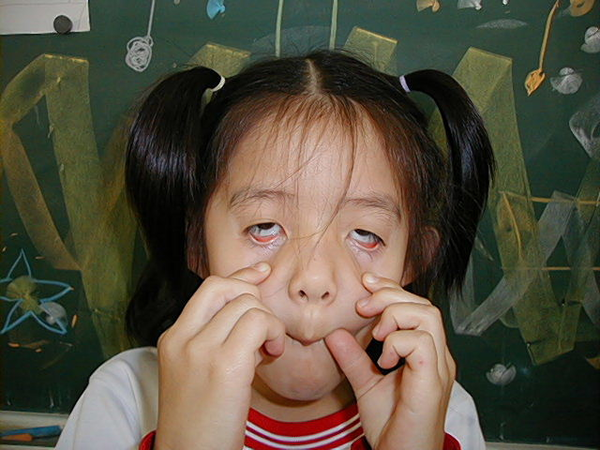寶玉
I feel the second winner is :

我覺得”第三恐怖”的鬼臉是：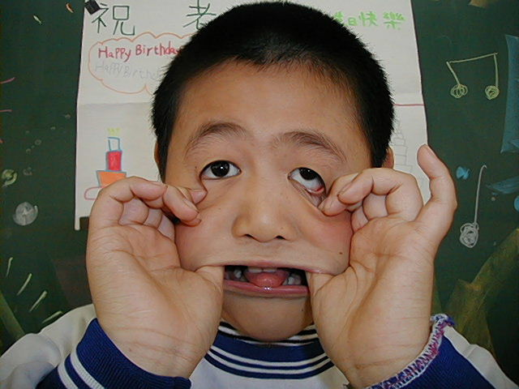百鴻

I feel the third winner is :

The most fuuny face
我覺得”第一可愛”的鬼臉是：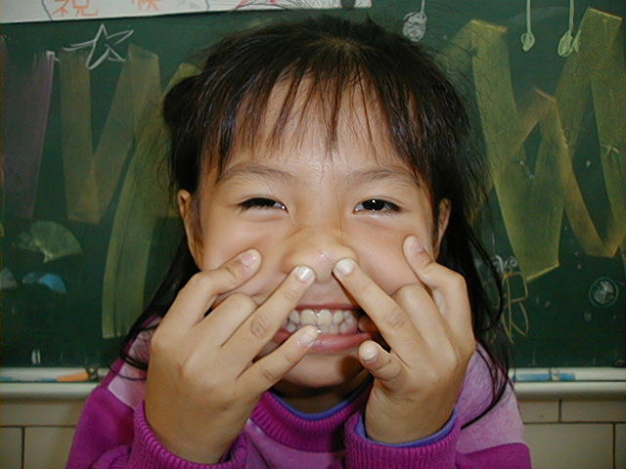營庭
I feel the first winner is :

我覺得”第二可愛”的鬼臉是：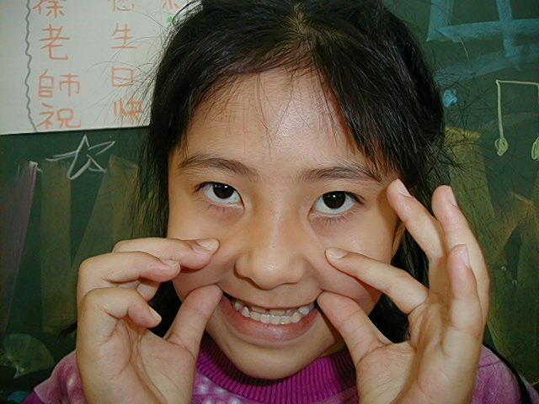營珊
I feel the second winner is :

我覺得”第三可愛”的鬼臉是：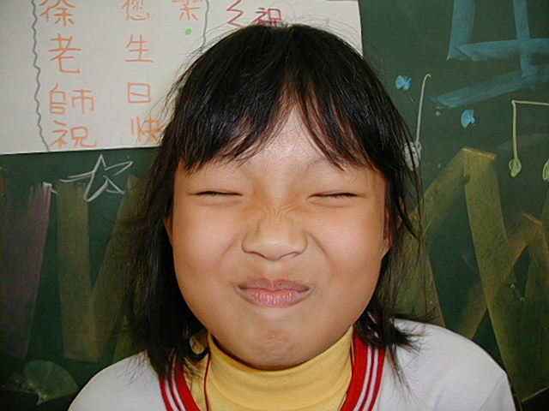淑緣
I feel the third winner is :

我的感想：好玩
My feeling：It’s funny!

