頂六國小三年智班扮鬼臉比賽學習單 我是：浩琦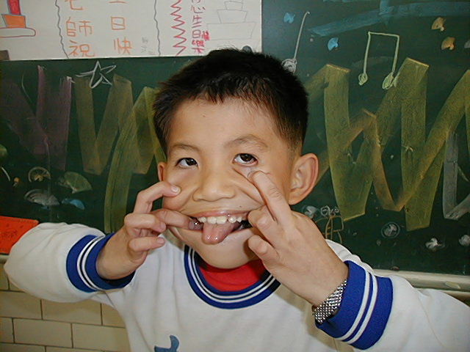
The worksheets of “funny face “game in 3A of Dinlio elementary school I am…

The most terrible face
我覺得”第一恐怖”的鬼臉是：弘偉
I feel the first winner is : 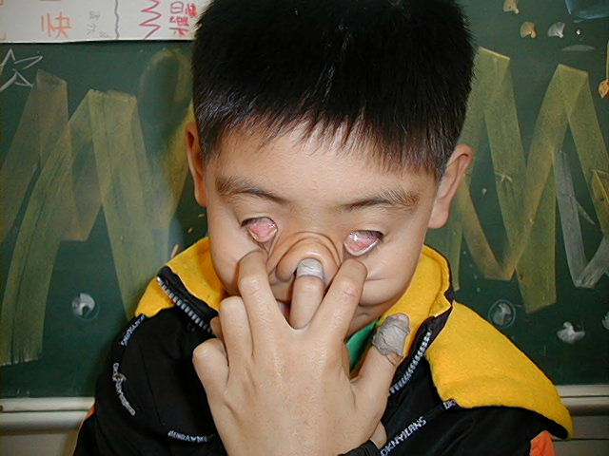

我覺得”第二恐怖”的鬼臉是：育勳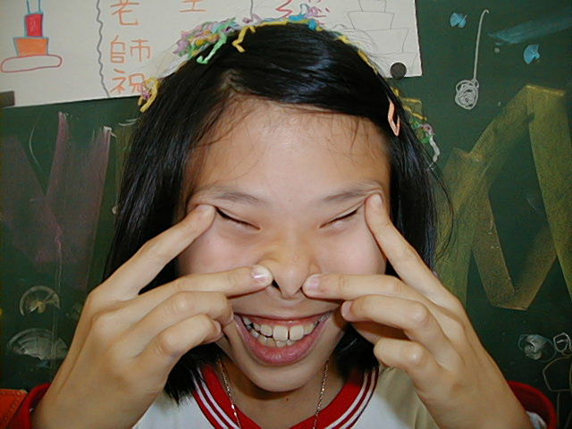
I feel the second winner is :

我覺得”第三恐怖”的鬼臉是：建杰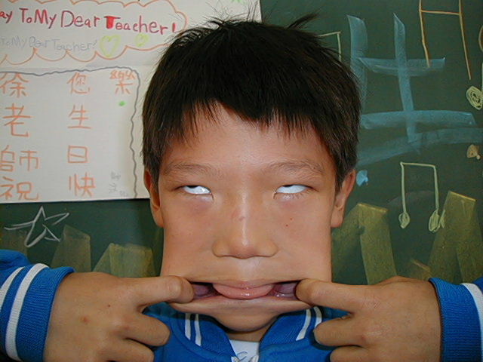
I feel the third winner is :

The most fuuny face
我覺得”第一可愛”的鬼臉是：宇軒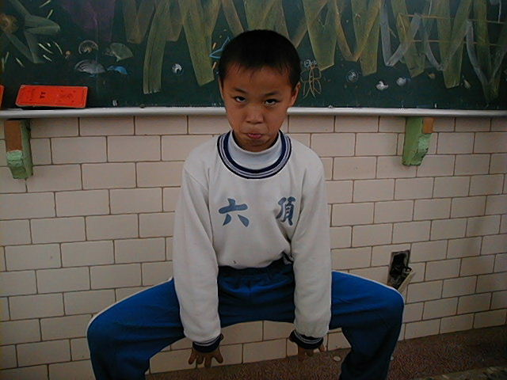
I feel the first winner is :

我覺得”第二可愛”的鬼臉是：睿之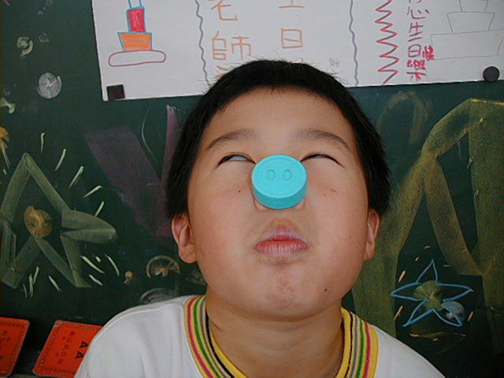
I feel the second winner is :

我覺得”第三可愛”的鬼臉是：昌麟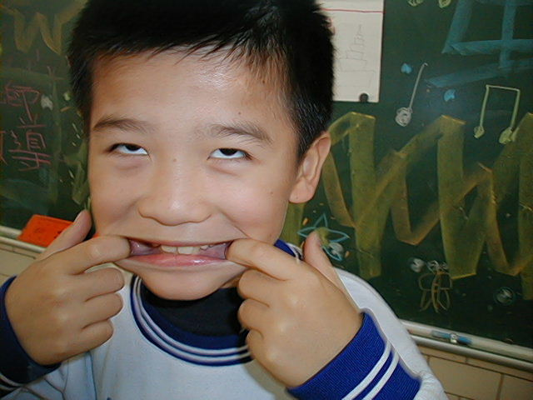
I feel the third winner is :

我的感想：我覺得扮鬼臉好玩又有趣，希望下一次還能舉行。
My feeling：There are interesting ,I hope ”funny face” next time.
,

