頂六國小三年智班扮鬼臉比賽學習單 我是：宇軒
The worksheets of “funny face “game in 3A of Dinlio elementary school I am…
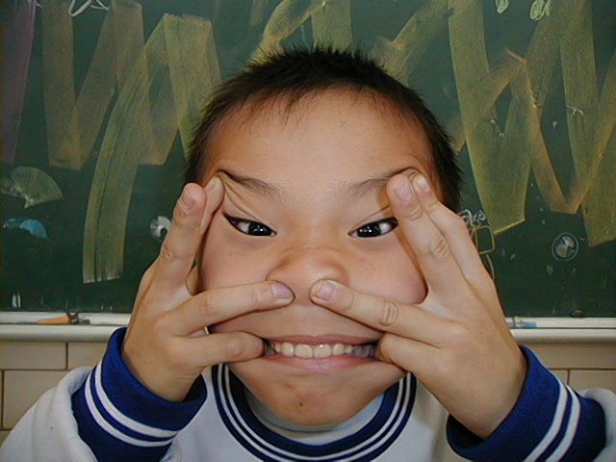

The most terrible face
我覺得”第一恐怖”的鬼臉是：弘偉
I feel the first winner is :
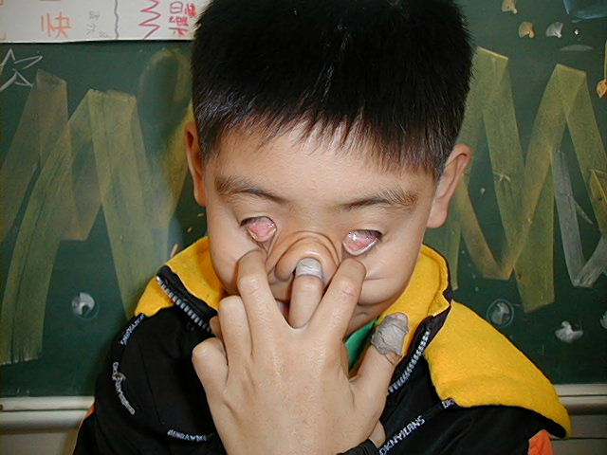
我覺得”第二恐怖”的鬼臉是：
I feel the second winner is :長奇
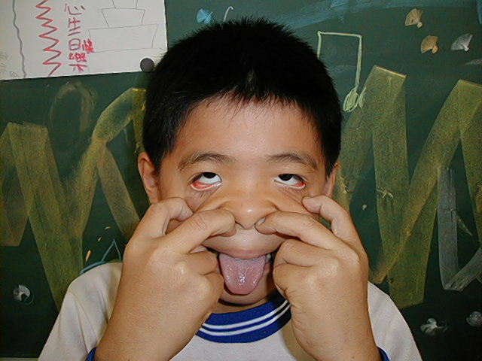
我覺得”第三恐怖”的鬼臉是：浩琦
I feel the third winner is :

The most fuuny face
我覺得”第一可愛”的鬼臉是：睿之
I feel the first winner is :
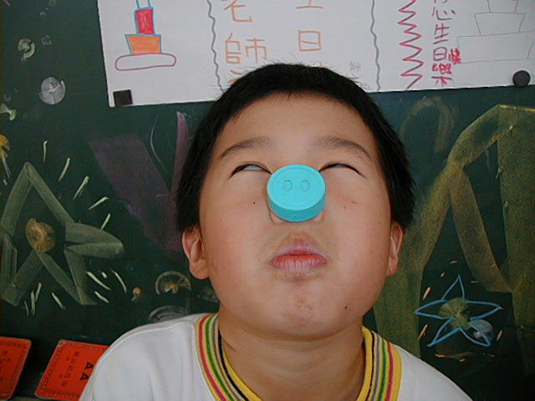
我覺得”第二可愛”的鬼臉是：建杰
I feel the second winner is :
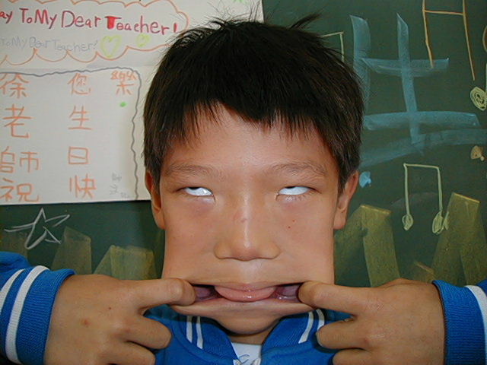
我覺得”第三可愛”的鬼臉是：翔尹
I feel the third winner is :
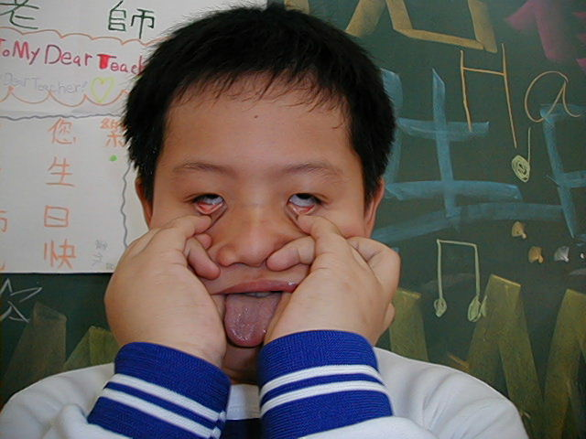

我的感想：我覺得扮鬼臉又有趣又好玩，下一次我還要再扮鬼臉給老師看。
My feeling：There are interest in fuuny face.Next time ,I will play “funny face” for our teacher.

