頂六國小三年智班扮鬼臉比賽學習單 我是：有仁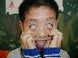
The worksheets of “funny face “game in 3A of Dinlio elementary school I am…

The most terrible face
我覺得”第一恐怖”的鬼臉是：景發
I feel the first winner is : 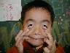

我覺得”第二恐怖”的鬼臉是：建杰
I feel the second winner is :
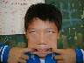
我覺得”第三恐怖”的鬼臉是：弘偉
I feel the third winner is :

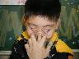

The most fuuny face
我覺得”第一可愛”的鬼臉是：玫苑
I feel the first winner is :
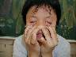
我覺得”第二可愛”的鬼臉是：昌麟
I feel the second winner is :
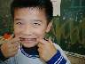
我覺得”第三可愛”的鬼臉是：薏如
I feel the third winner is :


我的感想：大家扮的鬼臉很好笑
My feeling:
Everybody play funny face!

